Unit 2 FR Questions AP Progress Check
- The nation of Kona cultivates coffee beans and cassava, from which all their consumer goods are produced. 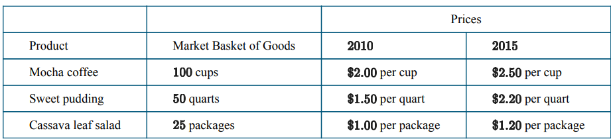
(a) Calculate the cost of the market basket of goods in the table in 2010 and in 2015. Show your work.
(b) Use as the base year to calculate the price indices for and for the market basket of goods in the table. Show your work.
(c) In order for a citizen of Kona to maintain the same standard of living between 2010 and 2015, what percentage change in nominal income would be needed? Explain

- The table below shows unemployment and labor force statistics for an economy.
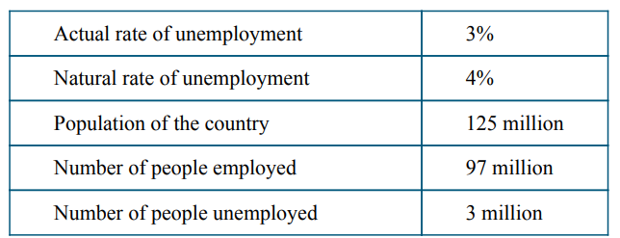
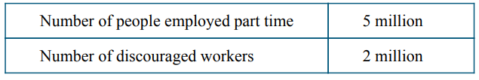
(a) Calculate the size of the labor force. Show your work.
(b) Calculate the labor force participation rate. Show your work.
(c) Given the state of the economy described in the table, is actual real output less than, greater than, or equal to potential real output? Explain.
(d) Calculate what the cyclical unemployment rate would be if the actual rate of unemployment increased to 5 percent. Show your work.
(e) Suppose discouraged workers reenter the labor force and find employment. Will the actual rate of unemployment increase, decrease, or stay the same?

Answers

A Calculates the cost of the 2010 Market Basket as $300 and shows appropriate work:
B calculates the cost of the 2015 Market Basket as $390 and shows appropriate work:
C Correctly calculates the 2010 (base year) index as 100 and shows appropriate work:
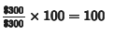
Correctly calculates the 2015 index as 130 and shows appropriate work:
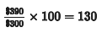
D The response should correctly calculate the inflation rate between 2010 and 2015 and explain that nominal income must rise by this inflation rate in order to maintain the same standard of living between 2010 and 2015. The value of the inflation rate must be consistent with the calculated percentage change of the price index in part (b).
Response states that nominal income must rise by 30 percent (the inflation rate) between 2010 and 2015 and explains that nominal income must rise by the inflation rate in order to maintain the same standard of living during this time period

2
A Response calculates the size of the labor force as 100 million and shows appropriate work.
B Response calculates the labor force participation rate as 80% and shows appropriate work.
C Response calculates the cyclical rate of unemployment as 1% and shows appropriate work:
D Response calculates the cyclical rate of unemployment as 1% and shows appropriate work:
E Response states that the actual rate of unemployment will decrease.

